**CS5543 Real-Time Big Data Analytics Project Increment I**

**Pooja Shekhar(23)**

* Project Title & Team Member

Real-time Object Detection & Tracking & Scene Recognition on Traffic Data in Real-time video.

– Pooja Shekhar

* Project Goal and Objectives

Object detection and tracking are important and challenging tasks in many computer vision applications such as surveillance, vehicle navigation, and autonomous robot navigation. Video surveillance in a dynamic environment, especially for humans and vehicles, is one of the current challenging research topics in computer vision. It is a key technology to fight against terrorism, crime, public safety and for efficient management of traffic. The work involves designing of the efficient video surveillance system in complex environments. In video surveillance, detection of moving objects from a video is important for object detection, target tracking, and behavior understanding. Detection of moving objects in video streams is the first relevant step of information and background subtraction is a very popular approach for foreground segmentation. In this thesis, we have simulated different background subtraction methods to overcome the problem of illumination variation, background clutter and shadows. Detecting and tracking of human body parts is important in understanding human activities. Intelligent and automated security surveillance systems have become an active research area in recent time due to an increasing demand for such systems in public areas such as airports, underground stations and mass events. In this context, tracking of stationary foreground regions is one of the most critical requirements for surveillance systems based on the tracking of abandoned or stolen objects or parked vehicles. Object tracking based techniques is the most popular choice to detect stationary foreground objects because they work reasonably well when the camera is stationary and the change in ambient lighting is gradual, and they also represent the most popular choice to separate foreground objects from the current frame. Surveillance networks are typically monitored by a few people, viewing several monitors displaying the camera feeds. It is very difficult for a human operator to effectively detect events as they happen. Recently computer vision research has to address ways to automatically some of this data, to assist human operators. Detecting and recognize objects inside video stream (object, face, ...) and auto-tag them using OpenCV library and classify the topic video relates to.

* System Features & Objectives

Details of it includes: -

- extract feature corresponding to a given metadata

- tracking these features across video frames

- learning from these features (clustering, classification, ...)

-tagging the learnt faces.

* Application Specification
* OpenIMAJ /SIFT
* More to come for Machine Learning (ML) aspect of project
* System Specification/Software Architecture
* Spark ML to assign probabilities of specific features in a frame
* Storm efficiently handle feature extraction from cell video data
* Kafka transferring video data between systems
* More to come at a later date as we develop ML portion of project
* Workflow : Training Data Feature Extraction

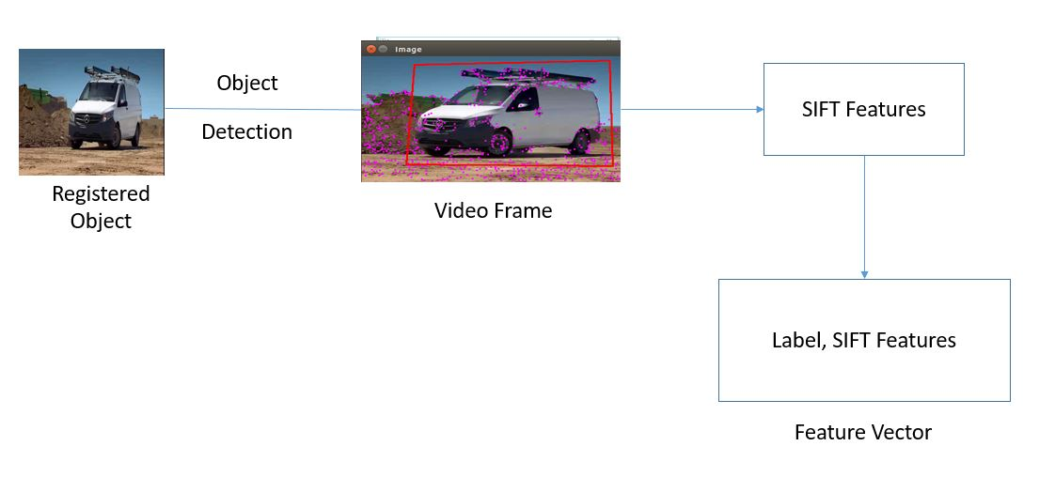

* Documentation
* Proposal:

<https://github.com/PoojaShekhar/CS5543-Real-Time-Big-Data-Analytics--Lab-assignments/blob/master/Project/Pre-Proposal.pdf>

* Lab3/4 (Clarifai for acquiring and applying image tags for frames; mainframe detection/ object detection/tracking):

<https://github.com/PoojaShekhar/CS5543-Real-Time-Big-Data-Analytics--Lab-assignments/wiki/Lab-3-4>

* Output

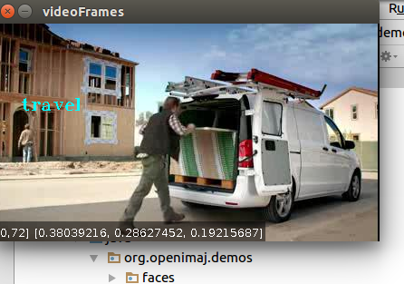

* Related Work

<http://autoscout.adsc.illinois.edu/applications/autoscout/>

* Projects done by others (include the URLs in Bibliography)
* <http://autoscout.adsc.illinois.edu/applications/autoscout/>
* <http://sparkbigdata.com/tutorials/104-case-studies>
* <https://books.google.com/books?id=TI3T9Yo7xkEC&pg=PA309&lpg=PA309&dq=video+analytics+motivation&source=bl&ots=aJMX5sqrQr&sig=iEty0gVZe4JRtM3oL00dWXQyyFc&hl=en&sa=X&ved=0ahUKEwiSi-S7qPnOAhVGbiYKHebwAMoQ6AEIQTAJ#v=onepage&q=video%20analytics%20motivation&f=false>